Good Morning  To All

Source code management using GIT AND GITHUB

Git Software [**click here**](https://git-scm.com/)

**Github account** [**Link**](https://github.com/)

**Git  and Github**

 What is Git ? 

* Git is a version control  system for tracking changes in computer files and coordinating work on those files among multiple people.
* It is mainly used for source code management in software development.
* It can be used to keep track of changes in any set of files.
* Versions shown in below figure.

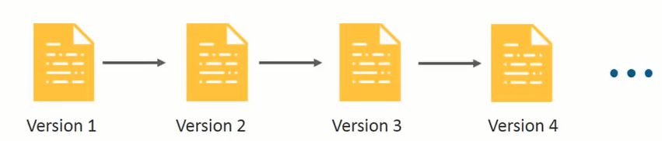

* Every commit has been stored in versions wise as shown in above figure.

**Basic Commands in Git:**

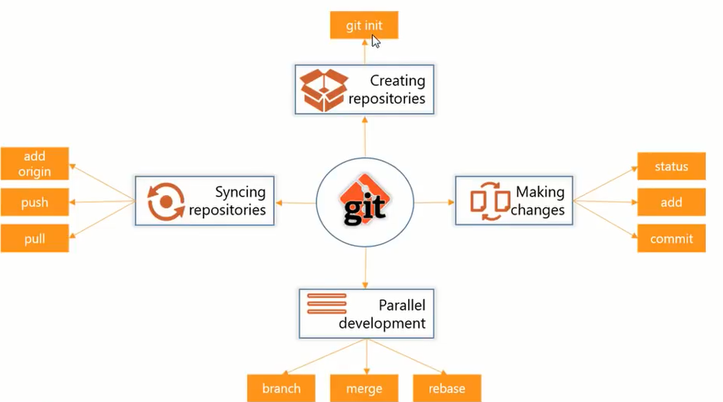

**First Time Git Configuration**

Before you can start using Git, you need to configure it. Run each of the following lines on the command line to make sure everything is set up.

***# sets up Git with your name***  
**git config --global user.name "<Your-Full-Name>"**  
  
***# sets up Git with your email***  
**git config --global user.email "<your-email-address>"**  
  
***# here we will get list of configs like username,email and other settings***   
**git config --list**

* For creating local repository(initializing the git in our local folder) by using

**git init**

* Their is in existing repository in github(Remote repository) we need to clone that by using

**git clone url(https://github/swamykankipati)**

* **After** cloning u will get your github repository into your cloning path,then u need to add(**staging**) the files by using following commands.

**git add ram.txt (or).jpg(or)any file extention for single file.**

**git add <file1> <file2> … <fileN>**

**git add .**

This command:

* takes a space-separated list of file names.
* alternatively, the period . can be used in place of a list of files to tell Git to add the current directory (and all nested files)

**git  add --a (or)git add --all for adding all files.**

* **I**f you need to remove(**unstage)**the staged files by using the following command.

**(use git rm --cached <file>... to unstage)**

* **A**fter adding all files u need to check the files either it added or not by using the following command.

**git  status(if u get green color then it is added)**

**(if u get red color then u need to add those files.)**

* **A**fter adding all files u need to commit all the staged files by using following commands.

**git commit -m “your message”**

***( # unique message for each commit.)***

* After committing completed you need to push the entair code into your Github Repository(global repository)by using the following command.

**git push origin main(G**ive your credentials and get code on           github)

* If u want to see the all commits then you will use following command

**git log**

* If u want to see the all commits in a single line then you will use following command

**git log --oneline**

* If u want to retrieve the previous commits then we will use following command

**git  checkout <7-char key>**

Attendances Link

[Link](https://docs.google.com/spreadsheets/d/1gz21T3FiFn6d44nivjYje7kcwOO0tFh79-Y8GT38it0/edit?usp=sharing)

Github

[Github Link](https://github.com/swamykankipati/WebDesigningReactJs)

Recording Videos Link

Day-1(26-10-2020)

[Link](https://transcripts.gotomeeting.com/#/s/e9340c4f387c962b3cd310247c13df50b41dc4544c33ab1c4ebafe4a01dfe73e)

Day-2(27-10-2020)

Day-3(28-10-2020)

Day-4(29-10-2020)

Day-5(30-10-2020)

Day-6(31-10-2020)